**Git:[versional control systems]**

version control system is nothing taking backup of data with timestamp before and archieving them and give them whenever we needed

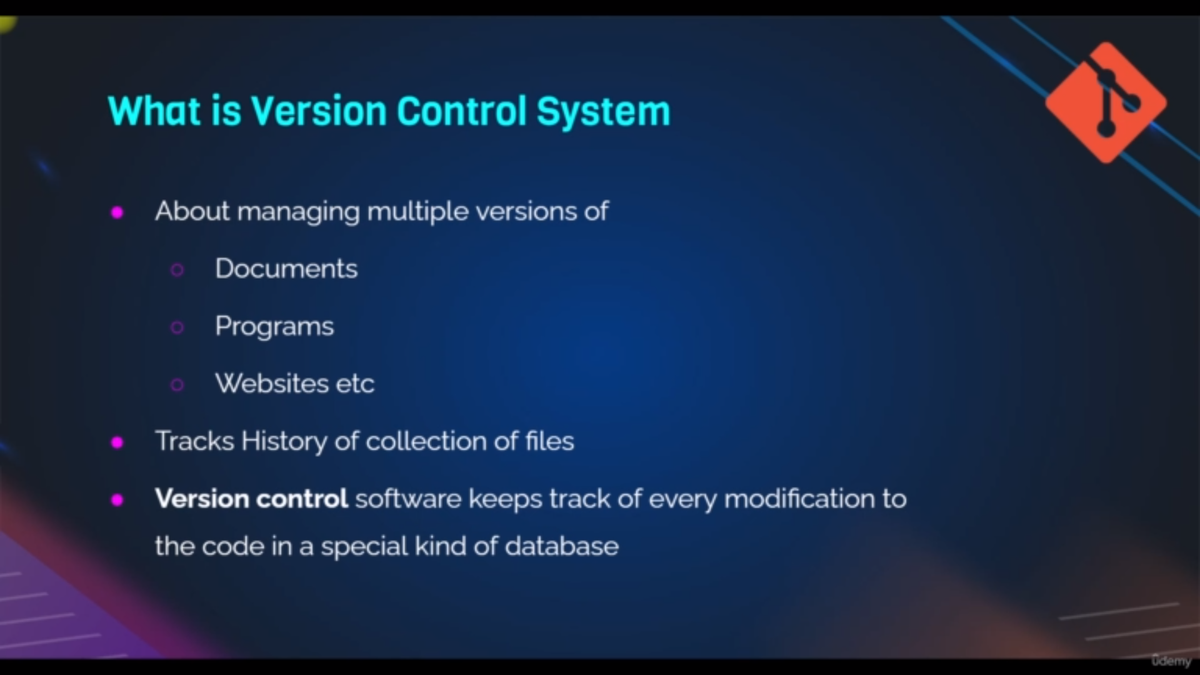definintion of versional control system

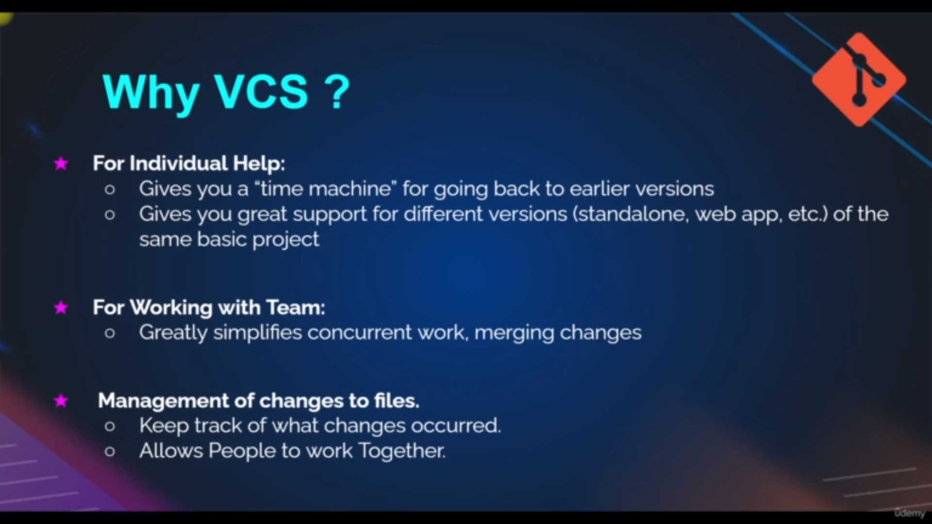uses of vcs

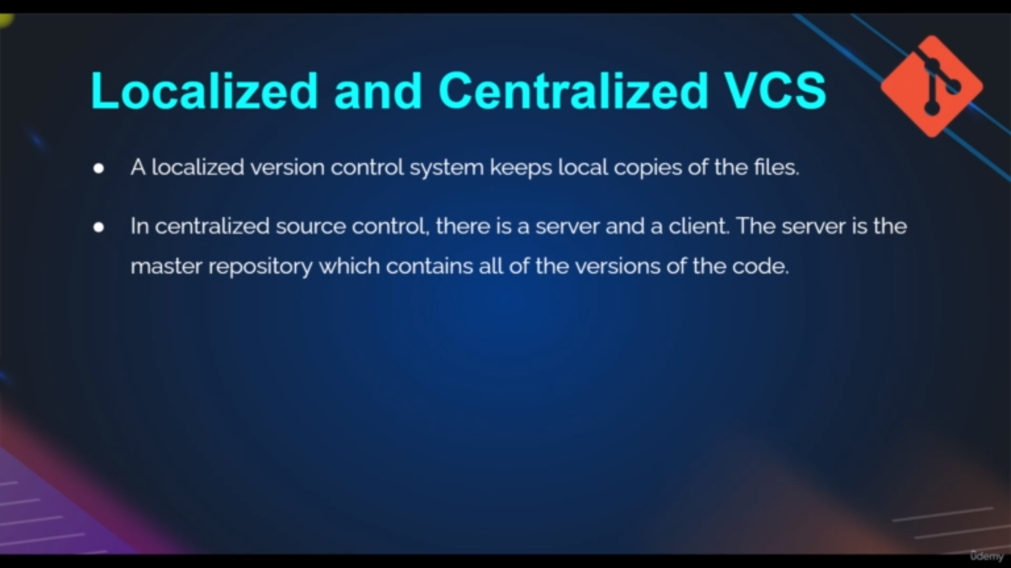types of vcs

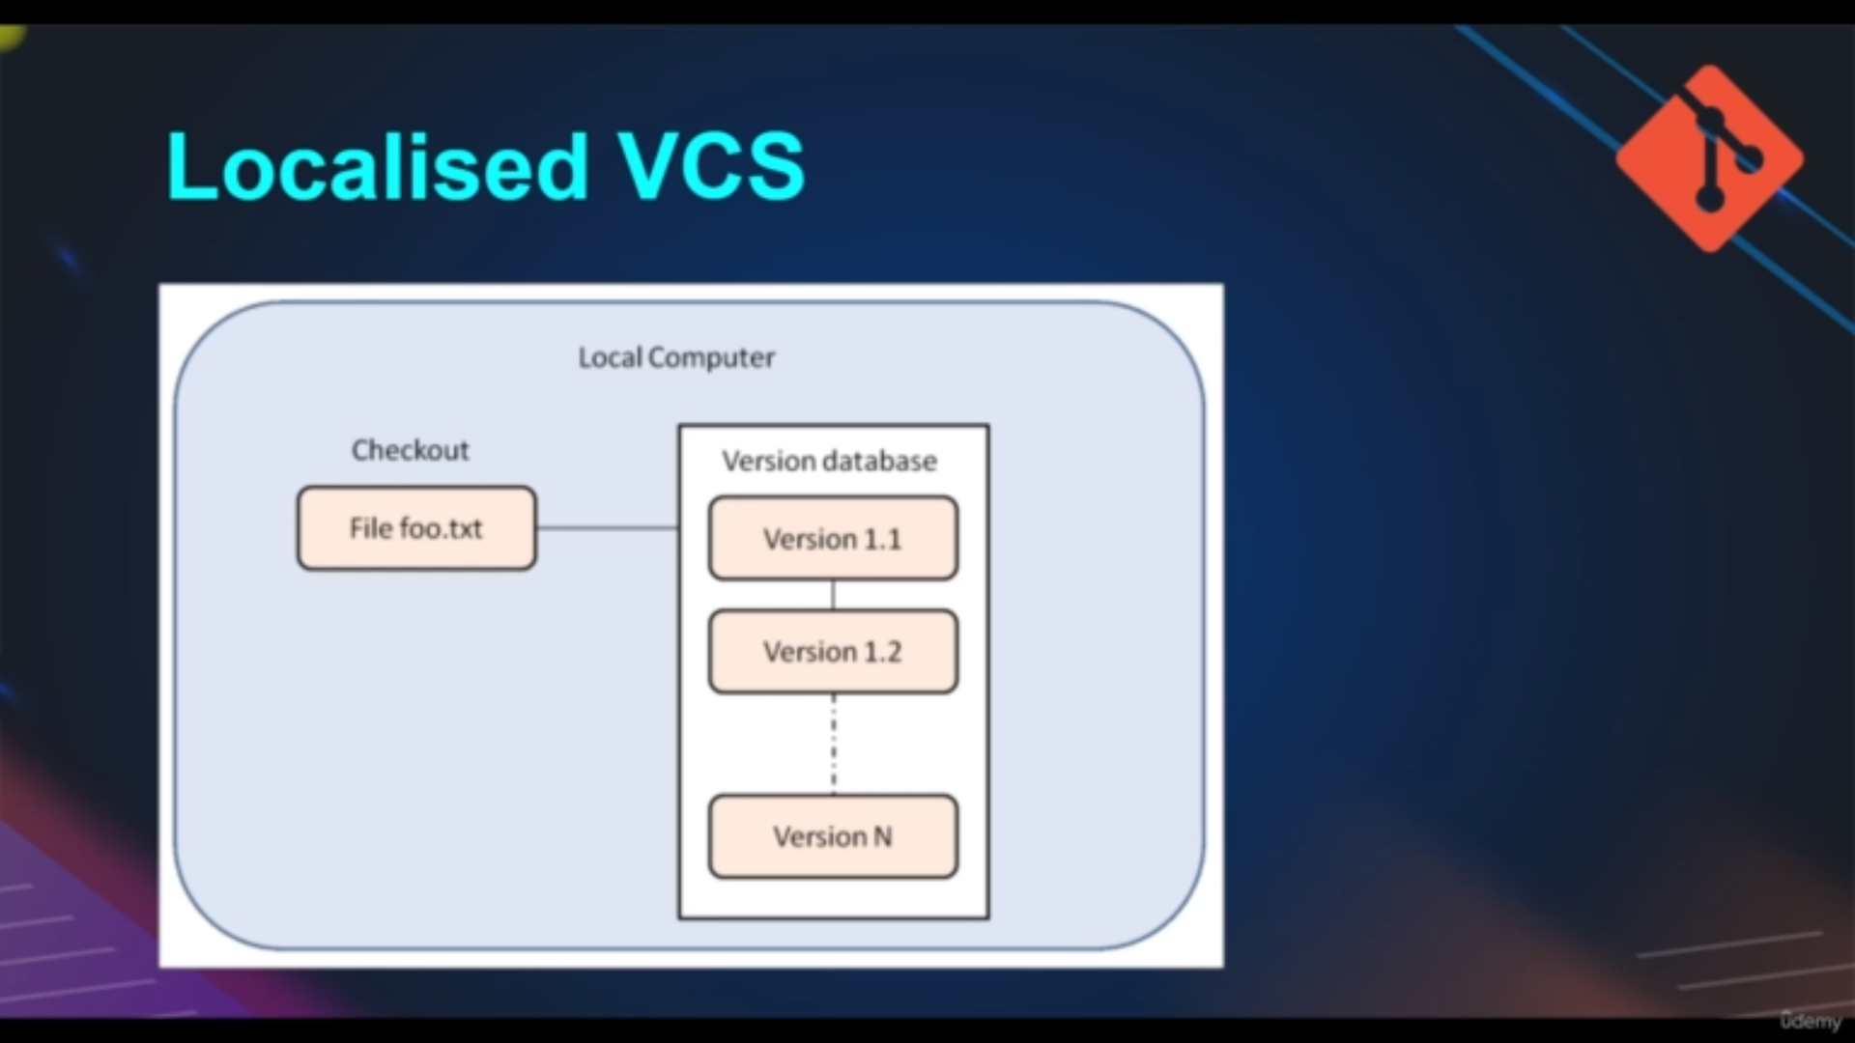independent user independent ,central repositery

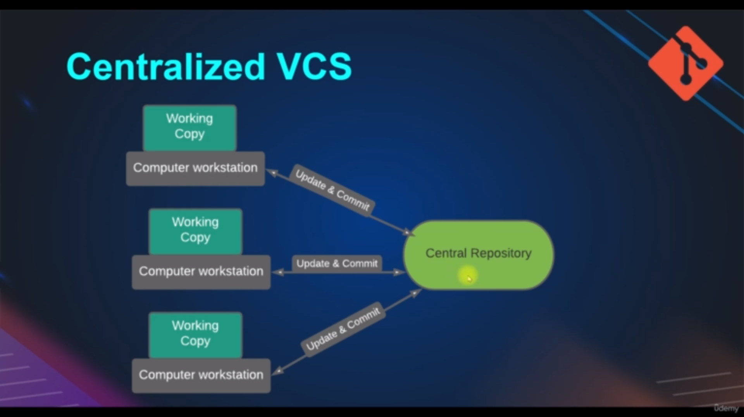multiple user and one centralized repositery

In this we have working copy there we changes and push it to the central repositery

multiple changes from multiple user cannot be possible

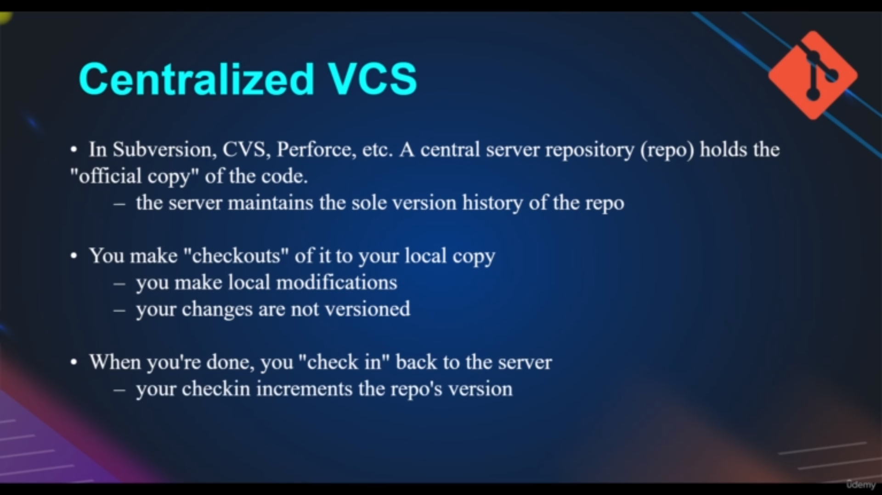uses of cvs

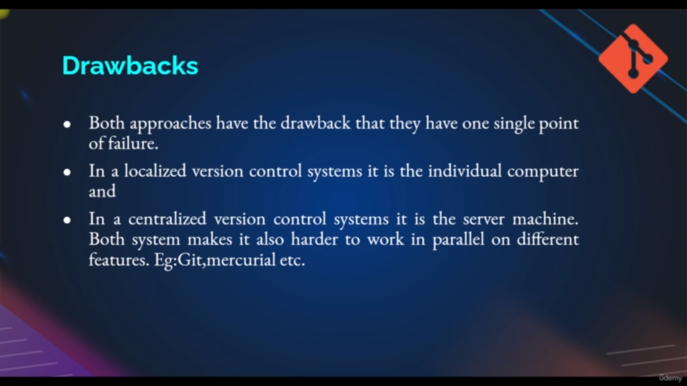drawbacks

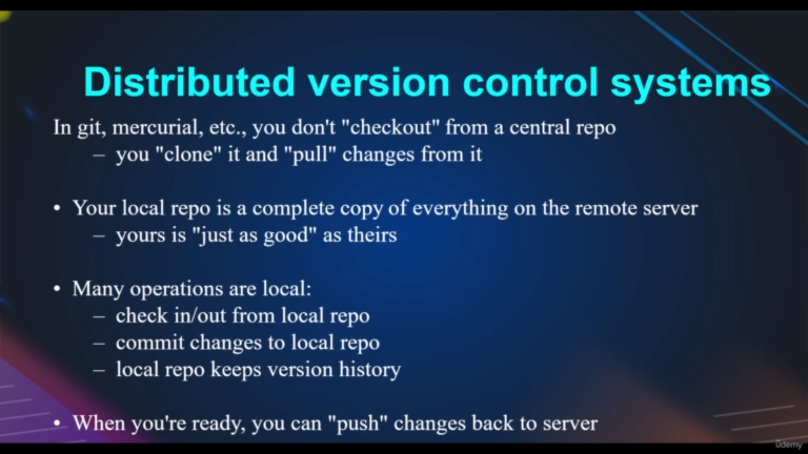uses of DVS

flow of Dvs

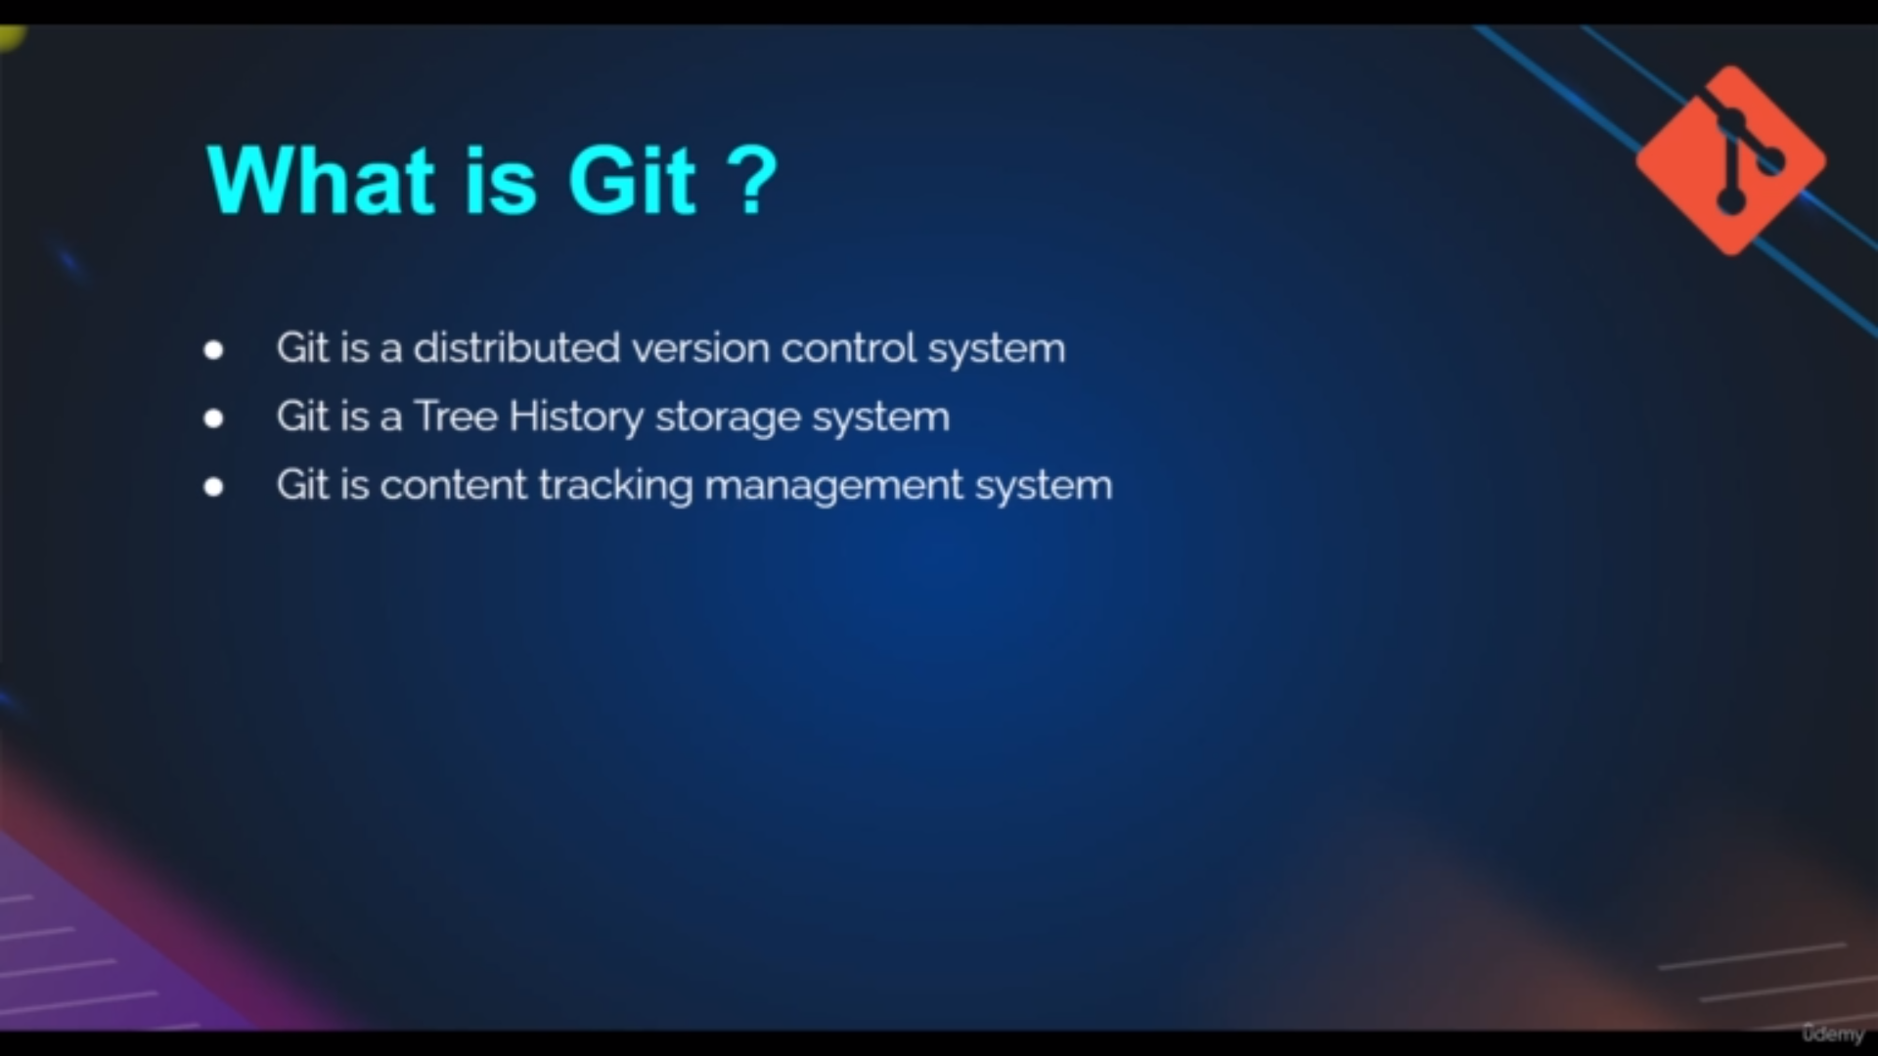Git definition

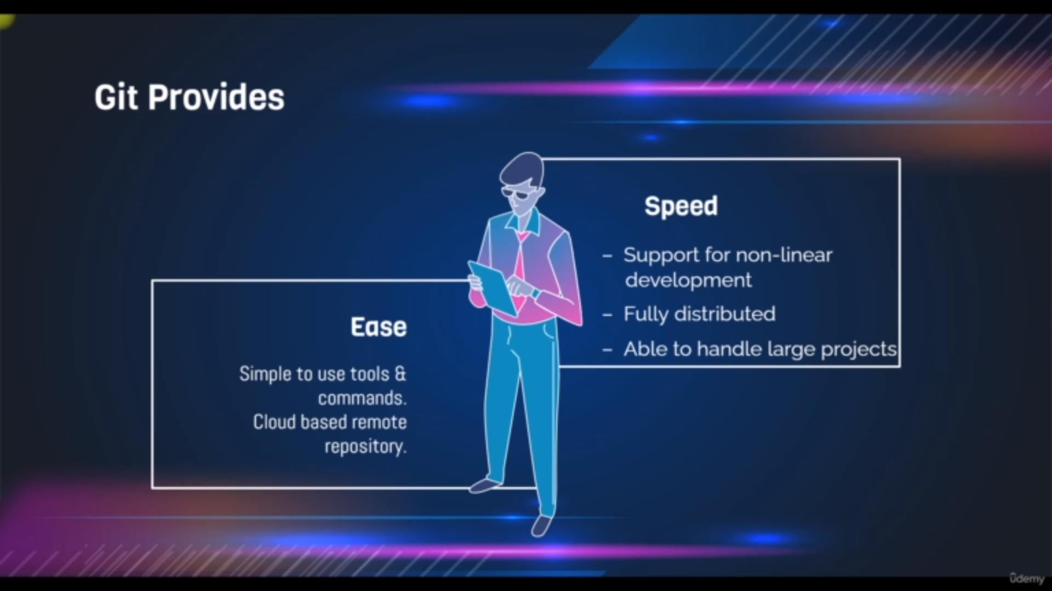uses of git